**How to integrate BrowserStack with Katalon**

1. Open BrowserStack page to get your desired capabilities settings:

<https://www.browserstack.com/automate/java#configure-capabilities>

1. Open “Project Settings” form to add capabilities to remote browser:

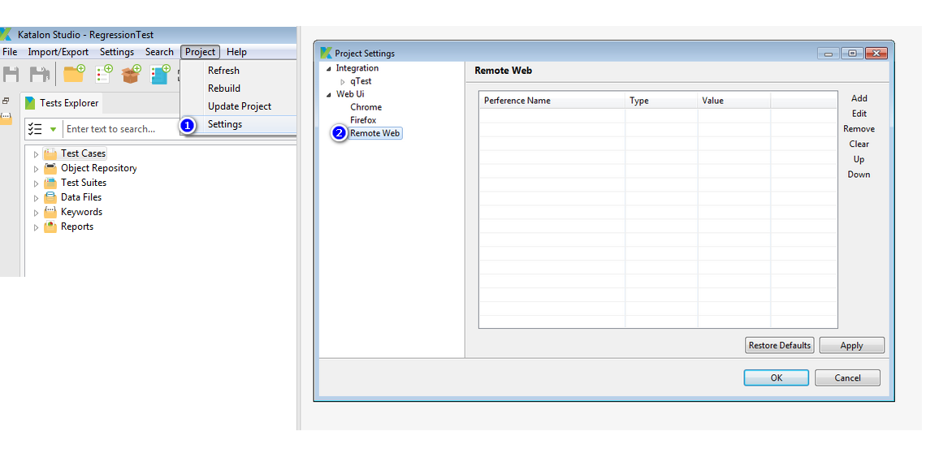

1. Map generated settings from BrowserStack using link from step 1. by adding them as preferences in Katalon. For example:

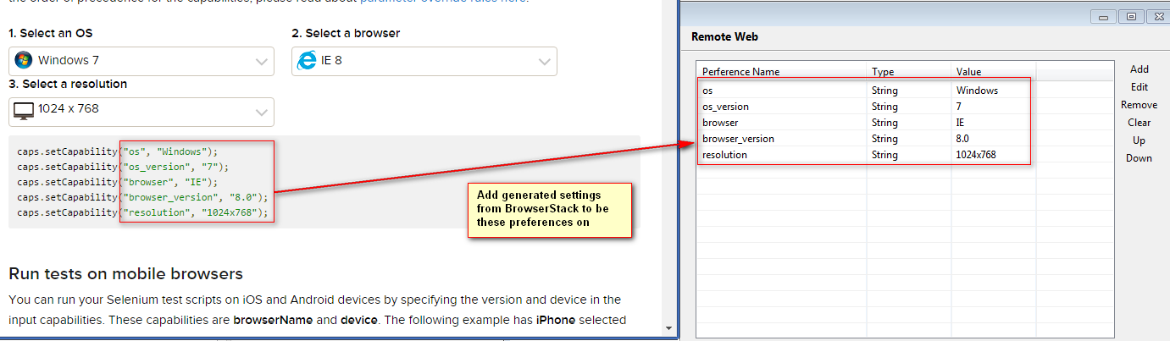

You need to do step 4 if you want to BrowserStack can access your local servers.Otherwise, just ignore below step

1. Install BrowserStack local from here: <https://www.browserstack.com/automate/java> and execute command per their guide.

**BrowserStackLocal.exe** pc4CL3bpYQiRL9g8xScL

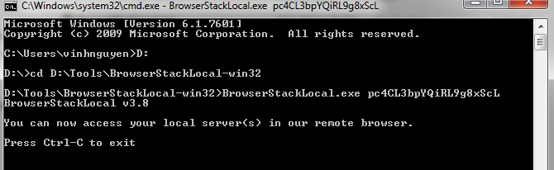

After that, you will need to add browserstack.local preference with value is “true” on the settings

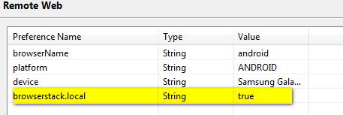

1. Run either your test case or test suite under remote mode:

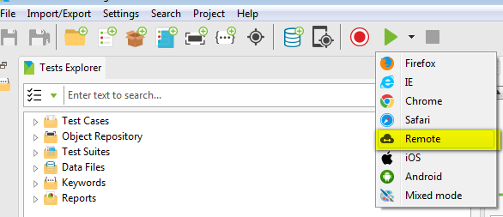

1. Add the remote web driver server URL on the dialog box. This server URL is provided to you from BrowserStack when you registered on them.

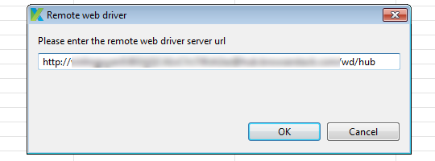

1. If your setup is well without any problems, you will see logs of execution using BrowserStack remote URL

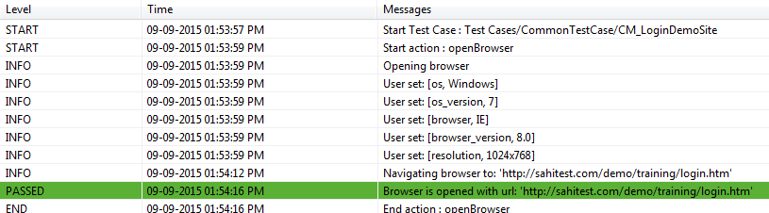

And also, remote machine screen will be available on BrowserStack dashboard for you by logging into:

<https://www.browserstack.com/users/sign_in>

Once you have logged in successfully, you can monitor running instance that you’ve setup

